The Big Triple Question Pack
Q1.
(a) The formula for the chemical compound magnesium sulphate is MgSO₄.
Calculate the relative formula mass (M_{r})of this compound. (Show your working.)
(2)
(b) Magnesium sulphate can be made from magnesium and dilute sulphuric acid.
This is the equation for the reaction.
Mg + H₂SO₄ → MgSO₄ + H₂
Calculate the mass of magnesium sulphate that would be obtained from 4g of magnesium.
(Show your working.)
Answer___________________ g
(2)
(Total 4 marks)
Q2.
A student investigated the reactions of copper carbonate and copper oxide with dilute hydrochloric acid.
In both reactions one of the products is copper chloride.
(a) Describe how a sample of copper chloride crystals could be made from copper carbonate and dilute hydrochloric acid.
(4)
(b) A student wanted to make 11.0 g of copper chloride.
The equation for the reaction is:
CuCO₃ + 2HCl → CuCl₂ + H₂O + CO₂
Relative atomic masses, A_{r}: H = 1; C = 12; O = 16; Cl = 35.5; Cu = 63.5
Calculate the mass of copper carbonate the student should react with dilute hydrochloric acid to make 11.0 g of copper chloride.
Mass of copper carbonate = _________________________ g
(4)
(c) The percentage yield of copper chloride was 79.1 %.
Calculate the mass of copper chloride the student actually produced.
Actual mass of copper chloride produced = ____________ g
(2)

(d) Look at the equations for the two reactions:
Reaction 1 CuCO₃(s) + 2HCl(aq) → CuCl₂(aq) + H₂O(l) + CO₂(g)
Reaction 2 CuO(s) + 2HCl(aq) → CuCl₂(aq) + H₂O(l)
Reactive formula masses: CuO = 79.5; HCl = 36.5; CuCl₂ = 134.5; H₂O = 18
The percentage atom economy for a reaction is calculated using:
Calculate the percentage atom economy for Reaction 2.
Percentage atom economy = ________________________ %
(3)
(e) The atom economy for Reaction 1 is 68.45 %.
Compare the atom economies of the two reactions for making copper chloride.
Give a reason for the difference.
(1)
(Total 14 marks)
Q3.
Citric acid is a weak acid.
(a) Explain what is meant by a weak acid.
(2)
A student titrated citric acid with sodium hydroxide solution.
This is the method used.
1. Pipette 25.0 cm³ of sodium hydroxide solution into a conical flask.
2. Add a few drops of thymol blue indicator to the sodium hydroxide solution.
Thymol blue is blue in alkali and yellow in acid.
3. Add citric acid solution from a burette until the end-point was reached.
(b) Explain what would happen at the end-point of this titration.
Refer to the acid, the alkali and the indicator in your answer.
(3)
(c) Explain why a pipette is used to measure the sodium hydroxide solution but a burette is used to measure the citric acid solution
(2)
(d) The table shows the student’s results.

 | Titration 1 | Titration 2 | Titration 3 | Titration 4 | Titration 5
Volume of citric acid solution in cm³ | 13.50 | 12.10 | 11.10 | 12.15 | 12.15
The equation for the reaction is:
C₆H₈O₇ + 3 NaOH ⟶ C₆H₅O₇Na₃ + 3 H₂O
The concentration of the sodium hydroxide was 0.102 mol / dm ³
Concordant results are those within 0.10 cm ³ of each other.
Calculate the concentration of the citric acid in mol / dm ³
Use only the concordant results from the table in your calculation.
You must show your working.
Concentration = ____________________ mol / dm ³
(5)
(Total 12 marks)
Q4.
In 1916, during the First World War, a German U-boat sank a Swedish ship which was carrying a cargo of champagne. The wreck was discovered in 1997 and the champagne was brought to the surface and analysed.
(a) 25.0 cm³ of the champagne were placed in a conical flask.
Describe how the volume of sodium hydroxide solution needed to react completely with the weak acids in 25.0 cm³ of this champagne can be found by titration, using phenolphthalein indicator.
Name any other apparatus used.
(4)
(b) The acid in 25.0 cm³ of the champagne reacted completely with 13.5 cm³ of sodium hydroxide of concentration 0.10 moles per cubic decimetre.
Calculate the concentration in moles per cubic decimetre of acid in the champagne.
Assume that 1 mole of sodium hydroxide reacts completely with 1 mole of acid.
Concentration = _____________ moles per cubic decimetre
(2)
(c) Is analysis by titration enough to decide whether this champagne is safe to drink?
Explain your answer.
(1)
(d) The graph shows how the pH of the solution changes during this titration.
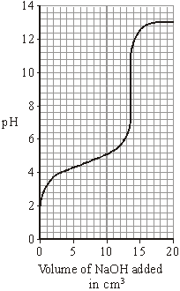
Phenolphthalein is the indicator used in this titration. It changes colour between pH 8.2 and pH 10.0.
Methyl orange is another indicator. It changes colour between pH 3.2 and pH 4.4.
Suggest why methyl orange is not a suitable indicator for this titration.
(2)
(Total 9 marks)
Q5.
Scientists found that a compound contained:
22.8% sodium; 21.8% boron; and 55.4% oxygen.
Use the percentages to calculate the empirical formula of the compound.
Relative atomic masses (A _{r}): B = 11; O = 16; Na = 23
To gain full marks you must show all your working.
Empirical formula = ______________________________
(Total 5 marks)
Q6.
This question is about reactions of ethanoic acid and the analysis of salts.
(a) Figure 1 shows the apparatus used to investigate the reaction of ethanoic acid with calcium carbonate.
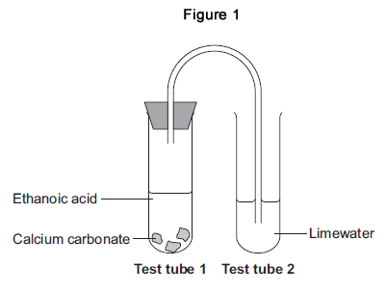
(i) Describe a change that would be seen in each test tube.
Give a reason for each change.
Test tube 1 ____________________________________________________
Test tube 2
(4)
(ii) Complete the displayed structure of ethanoic acid.
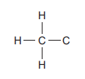
(1)
(iii) Ethanoic acid is a carboxylic acid.
Complete the sentence.
Carboxylic acids react with alcohols in the presence of an
____________ catalyst to produce pleasant-smelling compounds
called ______________ .
(2)
(b) Figure 2 shows four test tubes containing three different salt solutions and water.
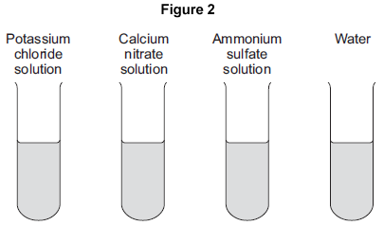
Each solution and the water was tested with:
• silver nitrate in the presence of dilute nitric acid
• barium chloride in the presence of dilute hydrochloric acid.
Complete the table of results.

 | Potassium chloride solution | Calcium nitrate solution | Ammonium sulfate solution | Water
Test with silver nitrate in the presence of dilute nitric acid |  |  | no change | no change
Test with barium chloride in the presence of dilute hydrochloric acid |  | no change | white precipitate
(2)
(c) Flame tests can be used to identify metal ions.
(i) Complete the following sentences.
The flame colour for potassium ions is ____________ .
The flame colour for calcium ions is ____________ .
(2)
(ii) Give one reason why a flame test would not show the presence of both potassium ions and calcium ions in a mixture.
(1)
(Total 12 marks)
Q7.
In this question you will be assessed on using good English, organising information clearly and using specialist terms where appropriate.
A group of students had four different colourless solutions in beakers 1, 2, 3 and 4, shown in the figure below.
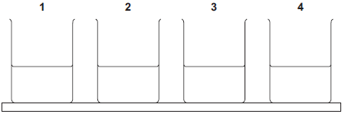
The students knew that the solutions were
• sodium chloride
• sodium iodide
• sodium carbonate
• potassium carbonate
but did not know which solution was in each beaker.
The teacher asked the class to plan a method that could be used to identify each solution.
She gave the students the following reagents to use:
• dilute nitric acid
• silver nitrate solution.
The teacher suggested using a flame test to identify the positive ions.
Outline a method the students could use to identify the four solutions.
You should include the results of the tests you describe.
(Total 6 marks)

Q8.
This question is about magnesium and magnesium chloride.
(a) Magnesium chloride contains magnesium ions (Mg²⁺) and chloride ions (Cl⁻).
Describe, in terms of electrons, what happens when a magnesium atom reacts with chlorine atoms to produce magnesium chloride.
(4)
(b) Magnesium chloride can be electrolysed.
The diagram below shows two experiments for electrolysing magnesium chloride.
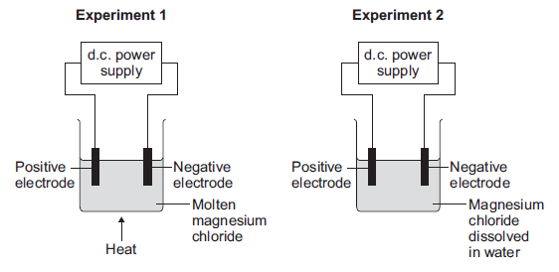
(i) Explain why magnesium chloride must be molten or dissolved in water to be electrolysed.
(2)
(ii) Explain how magnesium is produced at the negative electrode in Experiment 1.
(3)
(iii) In Experiment 2 a gas is produced at the negative electrode.
Name the gas produced at the negative electrode.
(1)
(iv) Suggest why magnesium is not produced at the negative electrode in Experiment 2.
(1)
(v) Complete and balance the half equation for the reaction at the positive electrode.
_____ Cl⁻ → Cl₂ + _____
(1)
(c) Magnesium is a metal.
Explain why metals can be bent and shaped. (2)
(Total 14 marks)

Q9. | David analyses a sample of a gas.  He finds it contains 1.2 g of carbon and 0.4 g of hydrogen.  Calculate the empirical formula for this gas.  empirical formula is ..........................  [2]

Q10. | The molecular formula of decene is C₁₀H_{20.}  What is the empirical formula of decene?  - CH₂  - C₂H₄  - C₅H₁₀  - C₂₀H₄₀  [1]

Q11. | Another compound found on Mars contains iron and oxygen.  The compound contains 70% by mass of iron and 30% by mass of oxygen.  Calculate the empirical formula of this compound.  The relative atomic mass, Ar, of O = 16 and of Fe = 56.  empirical formula is ...........................................................  [3]

Q12. | Look at the balanced symbol equation for the reaction of calcium carbonate with nitric acid.  CaCO₃ + 2HNO₃ → Ca(NO₃)₂ + CO₂ + H₂O  - David's experiment with nitric acid makes 60 cm³ of carbon dioxide at room temperature and pressure.  How many moles of carbon dioxide are made at the end of the reaction?  One mole of carbon dioxide has a volume of 24 000 cm³ at room temperature and pressure.  moles of carbon dioxide = .............................  [1]  - Calculate the mass of calcium carbonate needed to make this amount of carbon dioxide.  The relative formula mass, M_{r}, of calcium carbonate, CaCO₃, is 100.  mass of calcium carbonate = ............................. g  [1]

Q13. | Cristina titrates dilute nitric acid with sodium hydroxide solution.  Look at the diagram of her apparatus.  Cristina slowly adds dilute nitric acid into the flask until the end point is reached.  Cristina does four three more titrations.  Look at her results table.  Titration number 1 2 3 4  Final burette reading in cm³ 26.5 49.2 26.4 40.3  Initial burette reading in cm³ 0.0 24.1 1.2 15.0  Titre (volume of acid added) in cm³ 26.5 25.1 25.2 25.3  - Cristina calculates the mean titre to be 25.2 cm³.  Explain why this is the best mean value from these results.  [2]  - Cristina uses 10.0 cm³ of sodium hydroxide solution.  The concentration of the sodium hydroxide solution is 0.150 mol / dm³.  Calculate the number of moles of sodium hydroxide in 10.0 cm³ of this solution.  number of moles = .............................  [1]  - Look at the equation for the reaction between nitric acid and sodium hydroxide.  Use the information from parts (i) and (ii) to calculate the concentration of the nitric acid.  Give your answer to three significant figures.  concentration of nitric acid = .......................... mol / dm³  [2]

Q14. | Sara is neutralising dilute hydrochloric acid with potassium hydroxide solution.  Look at the diagram of the apparatus she uses.  Sara slowly adds 50 cm³ of potassium hydroxide solution to 30 cm³ of dilute hydrochloric acid.  She measures the pH of the solution in the flask as the potassium hydroxide solution is added.  Look at the graph of her results.  - What volume of potassium hydroxide solution must be added to get a pH of 12?  cm³ [1]  - What volume of potassium hydroxide solution is needed to exactly neutralise the hydrochloric acid?  cm³ [1]

(b). | - The concentration of the hydrochloric acid is 0.30 mol / dm³.  Show that 30 cm³ of this solution contains 0.009 moles of hydrochloric acid.  [1]  - Look at the equation for the reaction.  HCl + KOH → KCl + H₂O  Use your answers to parts (a)(ii) and (b)(i) to calculate the concentration of the potassium hydroxide solution.  concentration of potassium hydroxide solution = mol / dm³ [2]

Q15. | Molten aluminium oxide contains Al³⁺ and O²⁻ ions.  The electrolysis of molten aluminium oxide makes aluminium and oxygen.  - Write the balanced symbol equation for the electrode reaction that happens at the cathode.  Use the symbol e⁻ to represent an electron.  [1]  - Solid aluminium oxide cannot be electrolysed.  Explain why.  [1]

(b). | Aluminium is extracted from its ore using electrolysis.  Copper is extracted from its ore by heating with carbon.  Explain why different methods are used to extract aluminium and copper.  [2]

Q16. | Iron rusts in the presence of oxygen and water.  Look at the equations for two reactions that happen during rusting.  Which reaction is oxidation and which is reduction?  Explain your answer.  [2]

Q17. | The copper Sam makes is impure.  Look at the diagram. It shows the apparatus he useds to purify copper.  Look at the equations below for the electrode reactions.  The anode: Cu − 2e⁻ → Cu²⁺  The cathode: Cu²⁺ + 2e⁻ → Cu  - Which reaction is oxidation and which is reduction?  Explain why.  [2]  - Use the electrode reactions to explain why the anode loses mass and the cathode gains mass.  [2]

Q18 | Ammonia is made from nitrogen and hydrogen in an equilibrium reaction.  N₂(g) + 3H₂(g) ⇌ 2NH₃(g)  The forward reaction is exothermic.  Look at Table 1.  It shows the percentage of ammonia in the equilibrium mixture at 450 °C and different pressures.  Pressure in atmospheres Percentage (%) of ammonia at 450 °C  1 0.2  50 9.5  100 16.2  200 25.3  Table 1  Look at Table 2.  It shows the percentage of ammonia in the equilibrium mixture at 300 atmospheres and different temperatures.  Temperature in °C Percentage (%) of ammonia at 300 atmospheres  400 50  450 35  500 25  550 17  Table 2  Describe and explain how changing the pressure and changing the temperature affect the position of equilibrium in the reaction between nitrogen and hydrogen.  The quality of written communication will be assessed in your answer to this question.  [6]

Q19. | Meena electrolyses copper sulfate using copper electrodes.  Look at the diagram. It shows the apparatus she uses.  She investigates the change in mass at each electrode before and after the electrolysis.  Look at Meena's method.  1. Using a balance, measure the mass of the copper cathode and copper anode.  2. Set up the apparatus and run the electrolysis for 30 seconds.  3. Remove the copper cathode and the copper anode and immediately place them on the balance and measure their masses again.  Meena finds that  - the cathode gains mass  - the anode loses mass.  Explain these observations in terms of the reactions at each electrode.  [2]

Q20. | The reversible reaction between carbon dioxide and hydrogen makes methane and water.  In a sealed container this reversible reaction forms a dynamic equilibrium.  What is meant by the term dynamic equilibrium?  Refer to both concentration and rate of reaction in your answer.  [2]

Q21. | This question is about the Contact Process used for the manufacture of sulfuric acid.  Look at the flow chart for the process.  In the process, sulfur dioxide reacts with oxygen to make sulfur trioxide.  The forward reaction is exothermic.  Two of the conditions used are:  - a temperature of 450 °C  - a low pressure of 3 atmospheres.  Write down one other condition used in the process.  [1]

(b). | Explain the choice of conditions used in the process.  [3]

Q22. | Look at the displayed formula of ethene.  Bromine water is used to test for an alkene.  Ethene decolourises bromine water.  - What type of reaction is this?  [1]  - What type of compound is formed in this reaction?  [1]

Q23. | Ammonia is made from nitrogen and hydrogen in a reversible reaction, which reaches an equilibrium.  N₂(g) + 3H₂(g) ? 2NH₃(g)  Look at Table 1.  It shows the percentage of ammonia in the equilibrium mixture at 450 °C and different pressures.  Pressure in atmospheres Percentage (%) of ammonia at 450 °C  1 0.2  50 9.5  100 16.2  200 25.3  Table 1  Look at Table 2.  It shows the percentage of ammonia in the equilibrium mixture at 300 atmospheres and different temperatures.  Temperature in °C Percentage (%) of ammonia at 300 atmospheres  400 50  450 35  500 25  550 17  Table 2  The reaction between nitrogen and hydrogen is a reversible reaction, which reaches an equilibrium.  What is meant by a reversible reaction which reaches an equilibrium?  How does changing the pressure and temperature affect the position of equilibrium?  The quality of written communication will be assessed in your answer to this question.  [6]

